### RASPBERRY PI NETWORK ATTACHED STORAGE

Paladugu Reshvanth

### Computer networks – Course Project Formatting Instructions

1. Chapter number and Chapter heading – font size 16, upper case, bold.
2. Space between Chapter number and Chapter heading - double spacing.
3. Space between heading and contents – double spacing.
4. Abstract heading – font size 16.
5. Content of abstract – font size 14, double spacing.
6. Sample document is given below, follow it for font size, upper/lower case , spacing 7. Sub-heading example as follows.

3.3 REQUIREMENT SPECIFICATION (Times New Roman 14) 3.3.1 Hardware Requirements (Times New Roman 12)

Processor : 2.4 GHz Clock Speed RAM : 1 GB

Hard Disk : 500 MB (Minimum free space)

* + 1. Software Requirements

Operating System : Windows 7 Platform : Java

Back End : MySql

Special Tools : Opencv, Xuggle Server : Apache Tomcat

5

ACKNOWLEDGEMENT

We express our heartfelt thanks to our honorable Vice Chancellor Dr. C. MUTHAMIZHCHELVAN, for being the beacon in all our endeavors. We would like to express my warmth of gratitude to our Registrar Dr. S. Ponnusamy, for his encouragement

We express our profound gratitude to our Dean (College of Engineering and Technology) Dr. T. V.Gopal, for bringing out novelty in all executions. We would like to express my heartfelt thanks to the Chairperson, School of Computing Dr. Revathi Venkataraman, for imparting confidence to complete my course project

We wish to express my sincere thanks to Course Audit Professor Dr.M.LAKSHMI, Professor and Head, Data Science and Business Systems and Course Coordinator Dr.E. Sasikala, Associate Professor, Data Science and Business Systems for their constant encouragement and support.

We are highly thankful to my Course project Internal guide Subject handling staff name , Designation , Department, for his/her assistance, timely suggestion and guidance throughout the duration of this course project.

We extend my gratitude to the Student HOD name Department and my Departmental colleagues for their Support.

Finally, we thank our parents and friends near and dear ones who directly and indirectly contributed to the successful completion of our project. Above all, I thank the almighty for showering his blessings on me to complete my Course project

6

TABLE OF CONTENTS

**CHAPTERS CONTENTS PAGE NO.**

* + - 1. ABSTRACT
      2. INTRODUCTION
      3. REQUIREMENT ANALYSIS
      4. ARCHITECTURE & DESIGN
      5. IMPLEMENTATION
      6. EXPERIMENT RESULTS & ANALYSIS
         1. RESULTS
         2. RESULT ANALYSIS
         3. CONCLUSION & FUTURE WORK
      7. REFERENCES

Report Should contain minimum of 25 pages and maximum of 30 pages

7

# ABSTRACT:

The growing demand in the market for increased storage capacity is mainly because of our dependency on the Internet. Network Attached Storage (NAS) provides a dedicated file server to manage all kinds of files. It is an independent Storage device which is connected directly to the network. Due to its availability on the network it can be easily accessed by any number of heterogeneous clients.

The Network Attached Storage devices readily available in the market these days are highly overpriced and do not provide much scope for enhancements, another aspect which is to be taken into consideration is that in most instances these devices consume a fair amount of power. This proposed approach aims at providing a low cost NAS system which is easy to use and configure. It also comprises of added security features and Web Server capabilities. It enables you to have round the clock available storage device which is handy as well as power saving and allows accessibility to data on and off the network.

# INTRODUCTION:

The components/ softwares / protocols our NAS has are as follows:

→Raspberry pi

→Hard disk

→Ethernet cable

→HDMI cable

→Any desk software

→Open media vault

→SMB /samba protocol

### Raspberry pi:

Raspberry Pi is a series of small single-board computers (SBCs) developed in the United Kingdom by the Raspberry Pi Foundation in association with Broadcom.[15] The Raspberry Pi project originally leaned towards the promotion of teaching basic computer science in schools and in developing countries.[16][17][18] The original model became more popular than anticipated,[19] selling outside its target market for uses such as robotics. It is widely used in many areas, such as for weather monitoring,[20] because of its low cost, modularity, and open design. It is typically used by computer and electronic hobbyists, due to its adoption of HDMI and USB devices.

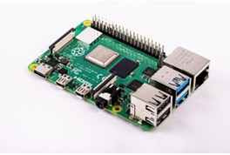

### Any desk software:

AnyDesk is a closed source remote desktop application distributed by AnyDesk Software GmbH. The proprietary software program provides platform independent remote access to personal computers and other devices running the host application.[9] Due to this, the program is often employed by internet scammers to take control of their victims computer over the internet.[10] It offers remote control, file transfer, and VPN functionality.



### Open media vault:

openmediavault is the next generation network attached storage (NAS) solution based on Debian Linux. It contains services like SSH, (S)FTP, SMB/CIFS, DAAP media server, RSync, BitTorrent client and many more. Thanks to the modular design of the framework it can be enhanced via plugins.

OpenMediaVault is primarily designed to be used in small offices or home offices, but is not limited to those scenarios. It is a simple and easy to use out-of-the-box solution that will allow everyone to install and administrate a Network Attached Storage without deeper knowledge.

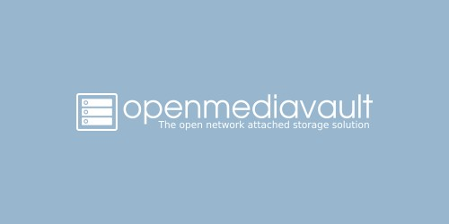

### SMB protocol:

In computer networking, Server Message Block (SMB), one version of which was also known as Common Internet File System (CIFS /sɪfs/), is a communication protocol[3] for providing shared access to files, printers, and serial ports between nodes on a network. It also provides an authenticated inter-process communication (IPC) mechanism. Most usage of SMB involves computers running Microsoft Windows, where it was known as "Microsoft Windows Network" before the introduction of Active Directory. Corresponding Windows services are LAN Manager Server for the server component, and LAN Manager Workstation for the client component.[4]

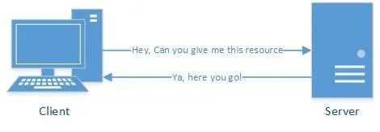

# REQUIREMENT ANALYSIS:

* + **A Raspberry Pi with all the trimmings: A** Raspberry Pi for this project is the most important requirement, along with the requisite accessories:
* A power supply
* A microSD card.
* And a mouse, a keyboard, and a monitor for the initial setup.
  + Any of the recent-model PIs should work for this project, and we will discuss more about how to get started with Raspberry Pi and its implementation in the upcoming category.
  + **A disc drive (or two, or three):** Unless it’s sharing just a few files, the microSD card probably isn't enough storage for a NAS. We will need some drives to fill up with your movies, music, or other files we want to share among devices. A standard [external drive](https://in.pcmag.com/hard-drive/40646/the-best-external-hard-drives-for-2020) will do the trick in most cases, though we may need one that plugs into the wall separately or a [powered](https://zdcs.link/YkpK4) [USB hub](https://zdcs.link/YkpK4), since the PI may not be able to supply enough power to all our drives. For a cleaner setup, we can use an [internal drive](https://zdcs.link/KlAEV) designed for network attached storage, too, but that would require a case.
  + **A NAS-friendly case (optional)**: If we want our system to have a clean look, it may behove to get an enclosure for our PI and drives, so it isn't just an octopus of wires and disks. For example, Geekworm makes a board called the **[X825](https://zdcs.link/RxNdV)** that allows you to dock a 2.5-inch internal hard drive, connect it to your PI, and mount it all in a [trim little case](https://zdcs.link/0N0Ve). (Just make sure you get one that's compatible with your PI—there are different cases for the PI 3, the PI 4, and so on.)
  + For now, we are using a standard Raspberry Pi case with a USB external drive Velcroed to the top, but if you're willing to get creative, the world is your oyster here. Once you have all your components in hand, it's time to get your NAS up and running.

# ARCHITECTURE & DESIGN:

The high level view of the architecture is as follows:

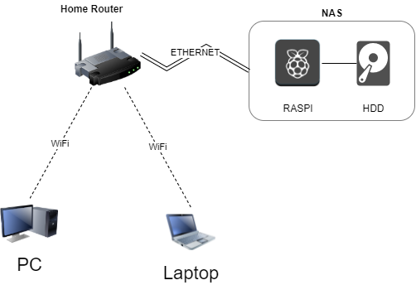

As seen from above, the RaspberryPi and HDD together constitute the NAS. The NAS is connected to the router via ethernet cable and is hosted locally on the network. We can then access the NAS via any windows/linux device on the same network by first specifying a network location(i.e. IP address of the raspi) and then entering the correct credentials.

# IMPLEMENTATION:

The NAS was implemented in a series of steps as follows:

### Installation of OpenMediaVault:

OpenMediaVault is the NAS solution software that we used. OpenMediaVault(OMV) is what allows you to create a NAS, make shared folders, set permissions, enable sharing, etc. So we first installed OMV on our raspberry pi.

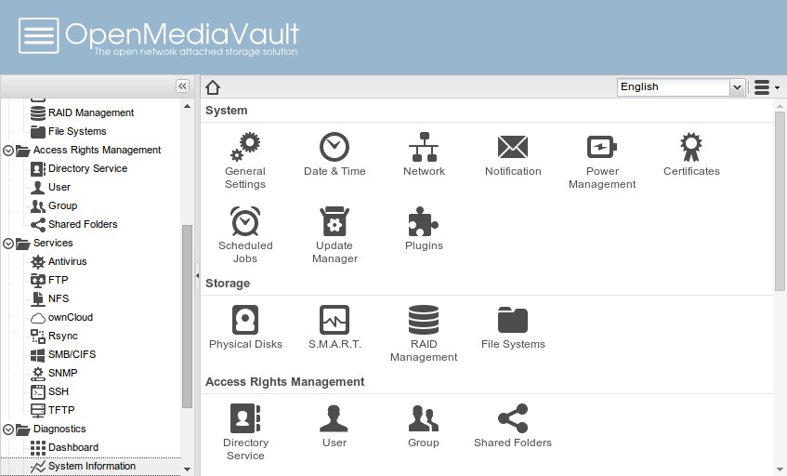

### Mounting hdd and making a shared folder:

The next step is to mount your hdd that’s connected to the raspberry pi and make a shared folder. This is the folder that will be shared with the entire network

### Enabling SMB sharing:

After making the shared folder, we need to enable SMB sharing so that windows devices can access this folder via SMB protocol. We simply go to “Services” in OMV, enable SMB, then add our shared folder to it.

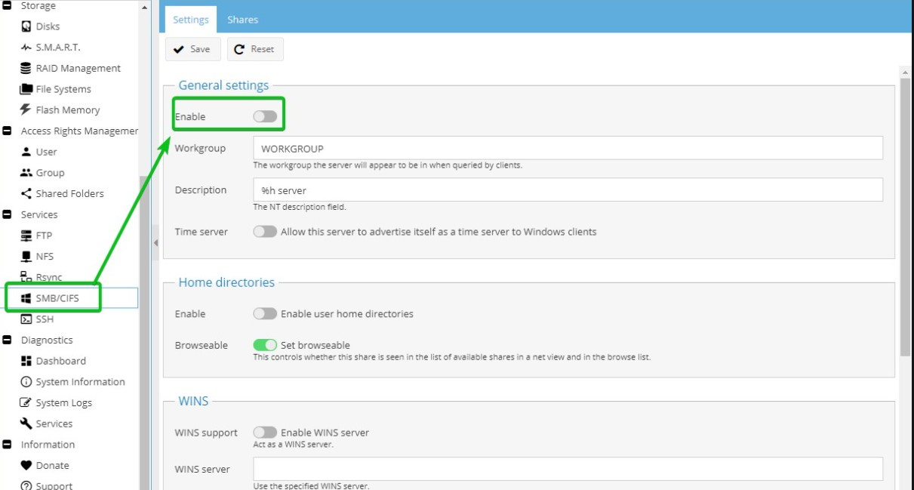

### Enabling NFS:

Like windows uses SMB, Linux devices use NFS protocol for file sharing. So we then need to enable NFS in OMV and add our shared folder there too.

### Setting permissions:

Now that we have set up our shared folder and the services we define which users are allowed to access this share. For this project, we have disabled guests and allowed only the “pi” user full read/write access to the share.

### Setup complete:

Now we have everything setup. We can access our shared folder from other devices by simply adding a “Network location”(i.e. Our Raspi’s IP address) to our pc in the file explorer. After adding the network location it’ll prompt you for the credentials of the raspberry pi. You can then access the NAS by entering the correct credentials.

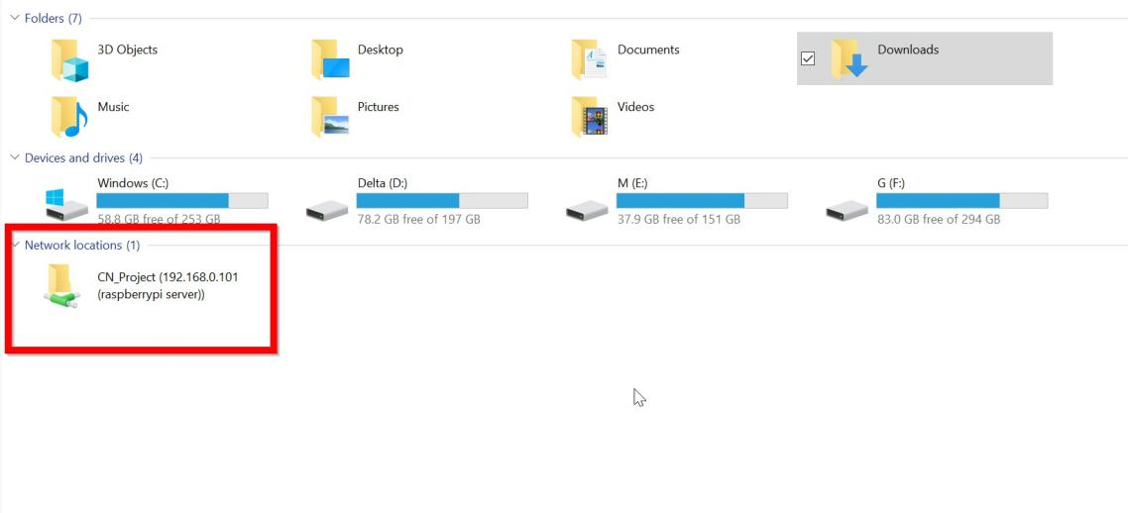

# EXPERIMENT RESULTS & ANALYSIS:

### RESULTS:

We have successfully implemented and established the Network Attached Storage using Raspberry PI.

**SETUP:**

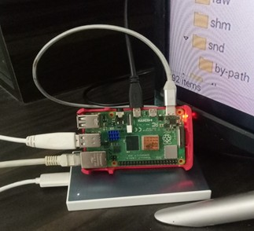

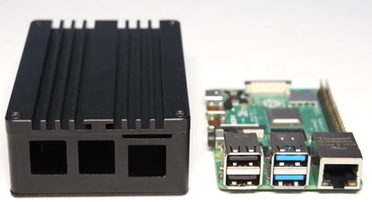

* 1. **RESULT ANALYSIS:**

**=> SYSTEM CONFIGURATION:**

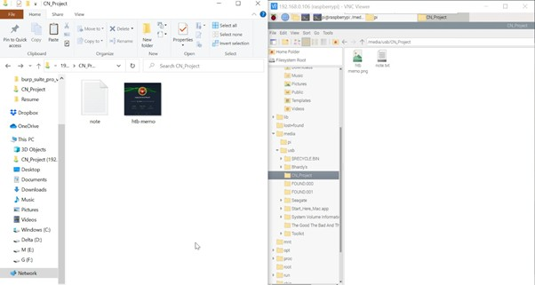

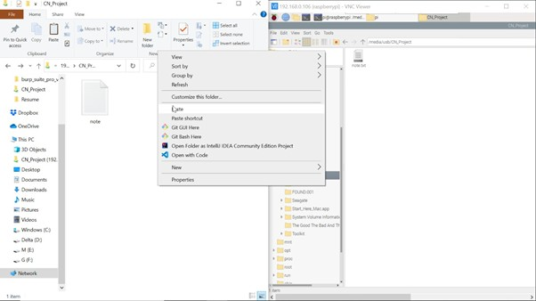

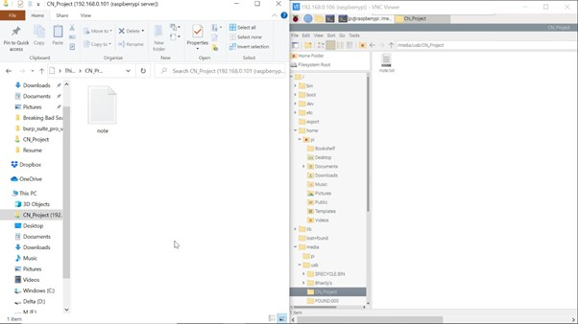

## CONCLUSION AND FUTURE WORK:

High-performance, low-latency networking is essential to achieving the potential of scalable network-attached storage. Software for the critical data in a LAN was developed. The software could perform backing up of files in remote nodes, deletion of files from remote nodes, retrieve files from remote nodes, join the group and unsubscribe from the group. The main objective of this project is to get thorough knowledge of the Raspberry PI board and about implementing NAS using commands in Linux or Windows operating systems.

## Future Scope:

* + - The number of businesses using voice over wireless ethernet LANs is set to triple in the next two years due to open-source IP phones.
    - Concentrates on the security issues which are handled.
    - Secure communication.
    - **Graphical user interface design:** As its clear from the screenshots or the demonstration of the web application (here we used OpenMediaVault), we must develop a much appealing web interface with better use of colours and more interactive tables.
    - **Drag and drop:** Further down the line, this feature to be implemented as drag and drop functionality in the web interface will allow files and folders to

be copied and moved on the file system with ease. These operations are quite complex to implement and require a large amount of JavaScript experience which we can achieve in the future.

# References:

* [https://medium.com/theteammavericks/wireless-nas-using-raspberry-pi-669d81883](https://medium.com/theteammavericks/wireless-nas-using-raspberry-pi-669d81883fdb) [fdb](https://medium.com/theteammavericks/wireless-nas-using-raspberry-pi-669d81883fdb)
* <https://www.ionos.com/digitalguide/server/configuration/raspberry-pi-nas/>
* <https://www.youtube.com/watch?v=gyMpI8csWis>